**Activity: Using reference queries**

[AdventureWorksSales](https://d3c33hcgiwev3.cloudfront.net/vI_S5iVOSr6M1jy3wz6x6Q_d72446391fc34bb09f3d25edbd9a3ae1_AdventureWorksSales.xlsx?Expires=1709856000&Signature=h-cbnKh3b7S39ndLYwqSApYltwui9YkI3hAJvaKAgMGJHL4Vu1YMAmqICgLcLO~9Mi4qq2HIdMUghd99BHQHpFQon2gyzGtUQWK8QBawUjjSpYqoeralAO547mjrzHa-DLZQfuWV9OObdwRVBRrBMXFgsB4-ObTJTW-qfA0cx0E_&Key-Pair-Id=APKAJLTNE6QMUY6HBC5A" \t "_blank)

[XLSX File](https://d3c33hcgiwev3.cloudfront.net/vI_S5iVOSr6M1jy3wz6x6Q_d72446391fc34bb09f3d25edbd9a3ae1_AdventureWorksSales.xlsx?Expires=1709856000&Signature=h-cbnKh3b7S39ndLYwqSApYltwui9YkI3hAJvaKAgMGJHL4Vu1YMAmqICgLcLO~9Mi4qq2HIdMUghd99BHQHpFQon2gyzGtUQWK8QBawUjjSpYqoeralAO547mjrzHa-DLZQfuWV9OObdwRVBRrBMXFgsB4-ObTJTW-qfA0cx0E_&Key-Pair-Id=APKAJLTNE6QMUY6HBC5A" \t "_blank)

[OtherSales](https://d3c33hcgiwev3.cloudfront.net/pl5p8m3nTEC8Vcd_ScC_qg_c22945e0043c4f33adeab731851cc5e1_OtherSales.xlsx?Expires=1709856000&Signature=KyUQnT98LvU15JN7wUOW4Z~iWcfk9uy1Ksxm87wRMlUc8KDcHRqQYYEKxN3F640thbU~qUSVqJkdgxWvBrIxM21K17XY0uqspSqluVGPIOZpah3U7Rmc5LgoqbiRiePb7WBJJzA6Fl17qKZWMHg~PlL5wh0lM1a05LNw-VYqMUw_&Key-Pair-Id=APKAJLTNE6QMUY6HBC5A" \t "_blank)

[XLSX File](https://d3c33hcgiwev3.cloudfront.net/pl5p8m3nTEC8Vcd_ScC_qg_c22945e0043c4f33adeab731851cc5e1_OtherSales.xlsx?Expires=1709856000&Signature=KyUQnT98LvU15JN7wUOW4Z~iWcfk9uy1Ksxm87wRMlUc8KDcHRqQYYEKxN3F640thbU~qUSVqJkdgxWvBrIxM21K17XY0uqspSqluVGPIOZpah3U7Rmc5LgoqbiRiePb7WBJJzA6Fl17qKZWMHg~PlL5wh0lM1a05LNw-VYqMUw_&Key-Pair-Id=APKAJLTNE6QMUY6HBC5A" \t "_blank)

**Introduction**

Microsoft Power BI provides a robust set of features that enables efficient data modeling and analysis. One of these powerful features is the ability to create reference queries. Reference queries allow you to reuse and reproduce changes across multiple queries. This reduces duplication of efforts and helps to ensure data consistency. In this reading, you will explore the benefits of using reference queries in Power BI and engage in a hands-on activity to reinforce how reference queries work.

**Reference queries**

With reference queries, you can create a master query that contains common data transformations and apply it to multiple dependent queries. Any changes made to the master query automatically replicate to all referencing queries. By leveraging reference queries, you can save significant time and effort when dealing with complex data transformations. Instead of recreating the same transformations multiple times, you can simply reference the master query and apply it to different datasets. This streamlined approach accelerates the data preparation process and allows you to focus on analysis and insights.

Reference queries offer a centralized approach to query maintenance. Instead of modifying transformations in each query, you can make updates in the master query, and those changes will be reflected in all referencing queries. Centralized maintenance simplifies query management, reduces the risk of errors, and improves overall query consistency. When you reference a query, the new query will have a single step: sourcing from the original query. The referenced query does not include the applied steps of the original query. If you make changes to the original query, then this new query will be impacted.

**Case study**

Adventure Works has recently acquired another bicycle business. Adventure Works’ lead data analyst and your manager, Adio Quinn, tasks you with creating a Power BI query that merges data from this new business. There are two Excel files containing sales data: Adventure Works’ sales data, named *AdventureWorksSales.xlsx*, and the other company’s data, named *OtherSales.xlsx*. The datasets have some common data such as SalesOrderID, SalesOrderDetailID, UnitPrice, and SalesData, and some other columns which do not have the same names.

Ordinarily, you’d have to rename the common columns in queries so that they match, remove unnecessary columns if they exist, and finally append them. However, your manager asked you not to change any of the existing queries, because they want to use those as the source for other operations. As a result, you are going to create references from the queries, update the new queries, and then append them. Any changes in the base query will impact the new queries. By doing this, you will preserve the original queries, update the reference queries, and reflect the changes to them.

**Instructions**

Create a new Power BI project called *Activity–Using reference queries*. Follow the prompts below to complete the activity.

**Step 1: Download the Excel files**

Download the *AdventureWorksSales.xlsx* and *OtherSales.xlsx* files to use in this activity.

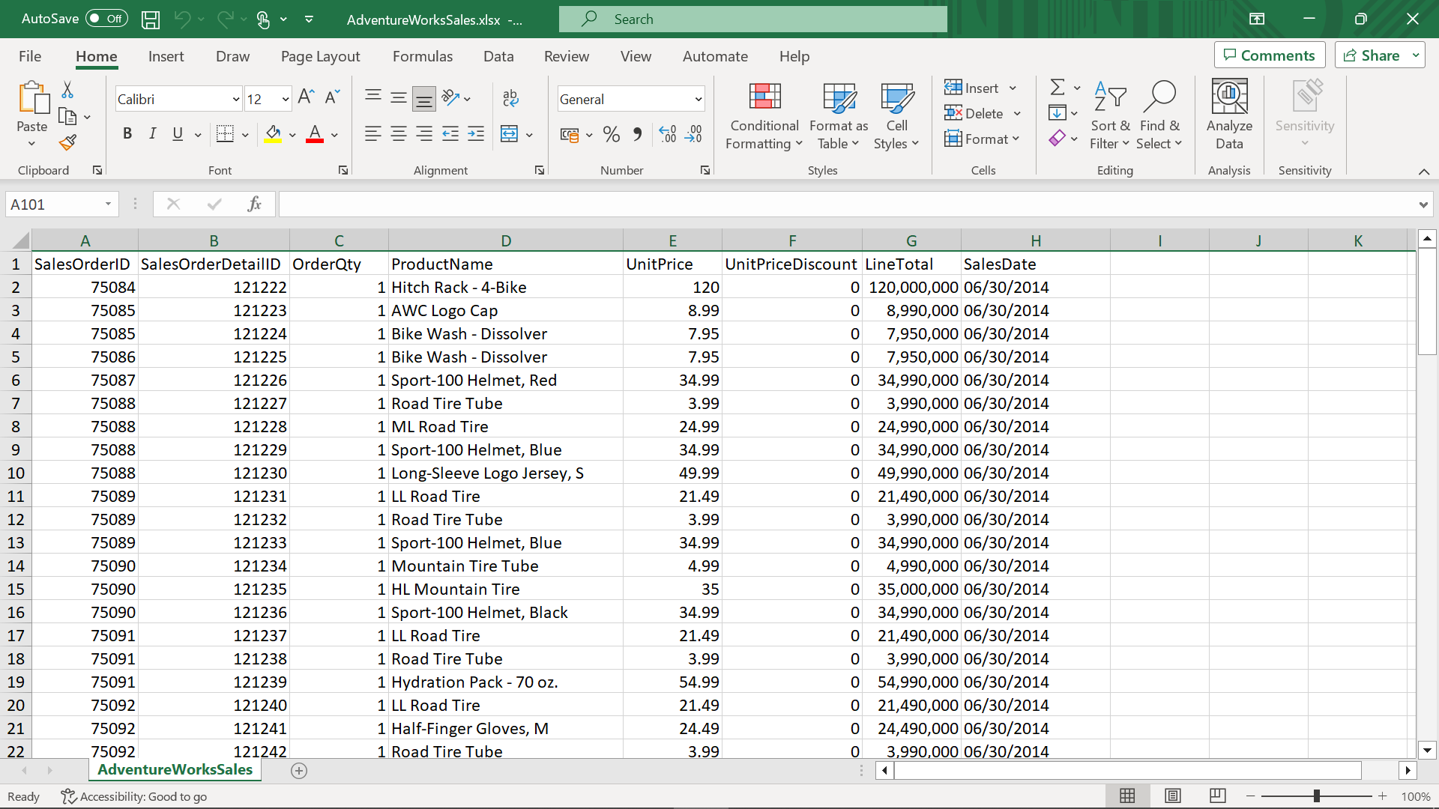

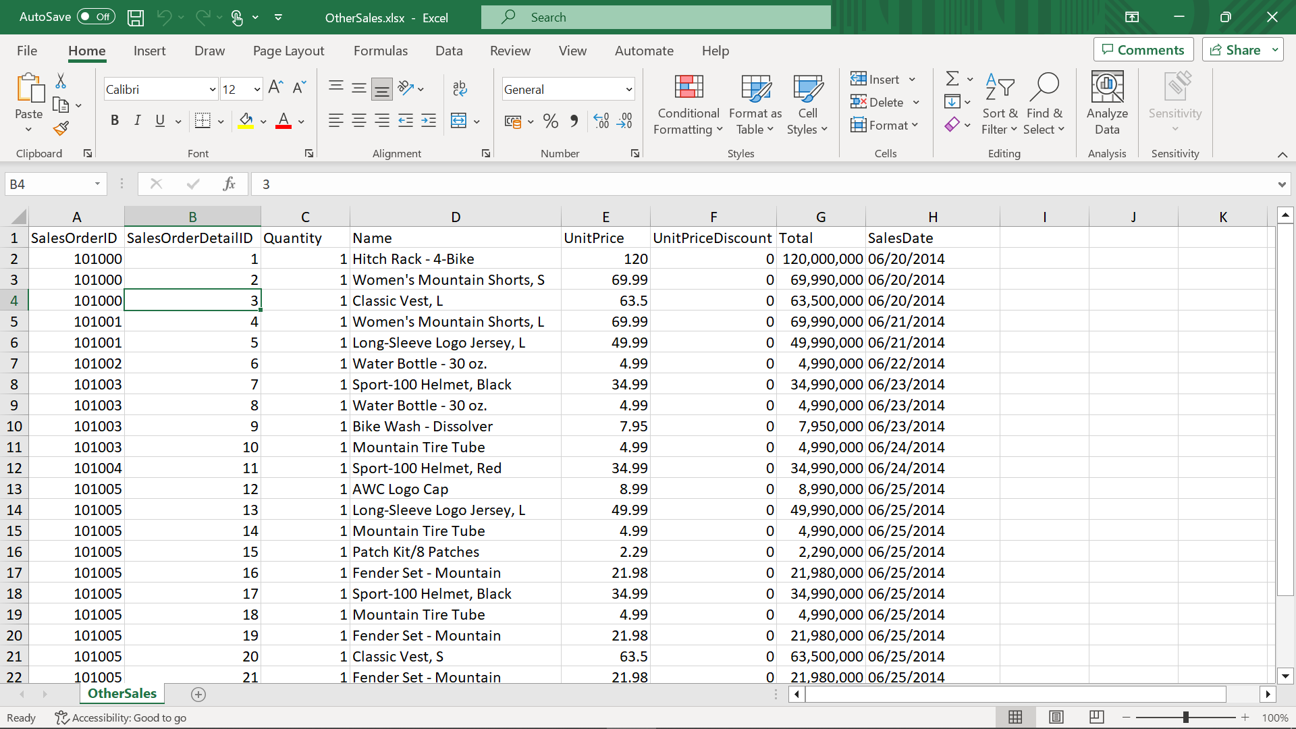

**Step 2: Open the Power Query Editor**

* Open the Power Query editor and import your datasets, *AdventureWorksSales.xlsx* and *OtherSales.xlsx*.

**Step 3: Reference queries**

Create reference queries from the datasets you imported using the instructions that follow:

1. Navigate to the left menu of the Power Query interface.
2. In the **Queries** pane, right-click the *AdventureWorksSales*file and select **Reference** in the menu. **Reference** will create a new query which is a copy of the *AdventureWorksSales*, but only contains one step.
3. Rename it as *AdventureWorksSales-Referenced*.
4. Repeat the previous steps for the *OtherSales* query.

**Step 4: Format Excel files**

To append *OtherSales-Referenced* data to *AdventureWorksSales*-*Referenced* data, you will use *AdventureWorksSales*-*Referenced* data as first table and *OtherSales-Referenced* data as the second table. For this reason:

1. Format the *OtherSales-Referenced* data.
2. Rename the columns using the *AdventureWorksSales-Referenceddata*. For example, change **Quantity** to **OrderQty**, **Name** to **ProductName**, and **Total** to **LineTotal**.

**Step 5: Append queries**

1. Select the queries you want to append the queries to a new master table by selecting them.
2. To append queries, navigate to the Home tab and choose **Append Queries as New** in the **Append Queries** menu.
3. Select the queries you want to append together and press **OK** to create a new master table.
4. In the **Queries** pane, select the **newly created query** and check its column names, row number, and the values appended to ensure that the operation is completed successfully.

**Step 6: Rename the new query**

1. In the left menu in Power Query, select the **new query** and change its name to *Consolidated Sales*.
2. In the **Properties** pane on the right, press **Enter**.

**Step 7: Uncheck the Enable Load**

1. You can prevent the original queries from loading, and saving memory in Power BI.
2. To do so, right-click the *AdventureWorksSales* query and uncheck the **Enable Load** option.
3. Repeat for the *OtherSales* query.

**Conclusion**

**Reference queries** are a powerful feature in Power BI that enables reusability, consistency, and centralized maintenance. By leveraging reference queries, you can streamline your data preparation process, save time and effort, and ensure consistency across multiple queries. The activity provided in this reading will help you get started with creating and using reference queries in Power BI. **Reference queries** will always reflect the latest data from the master query, allowing you to focus on analysis and generating valuable insights. Remember to regularly refresh the data in Power BI to ensure that your reports and visualizations are up to date with the latest sales information from the Adventure Works database. By using reference queries in your Power BI projects, you can unlock the full potential of query reusability and maintenance and experience enhanced efficiency and productivity in your data modeling and analysis endeavors.